Installation of Muller Panda 2 DC
(all creases facing the same direction)
Code QC-MU/PA-FP-6-01-DC
30mm shafts with 80mm outer diameter creasing unit

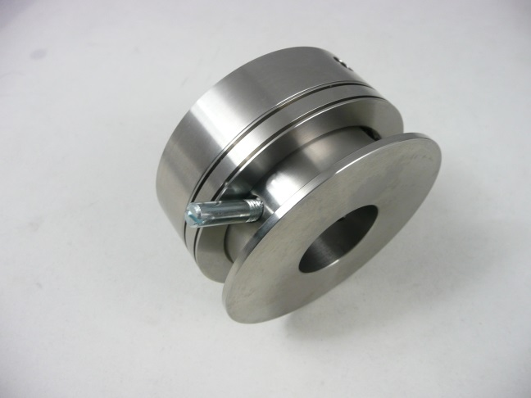
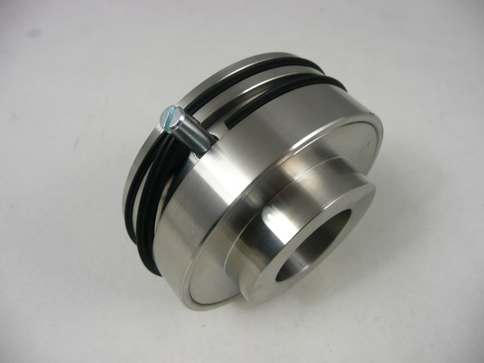
Top shaft Bottom shaft

Shaft pin locating holes
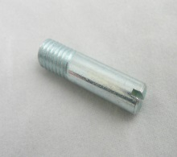

Top shaft Bottom shaft
Uses 2 x single wedge shaped crease ribs Uses a 2 female channels
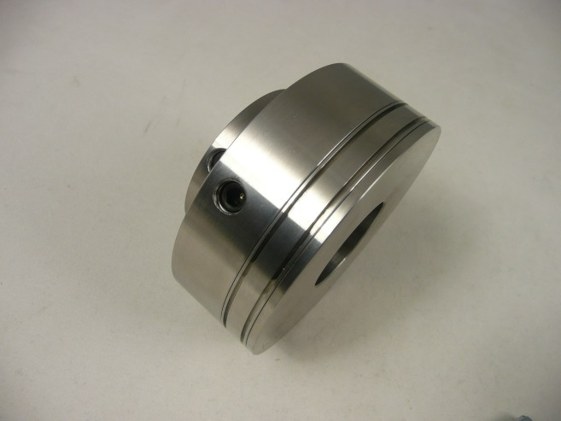
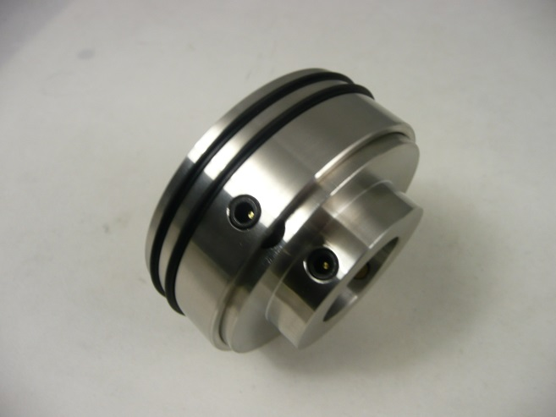

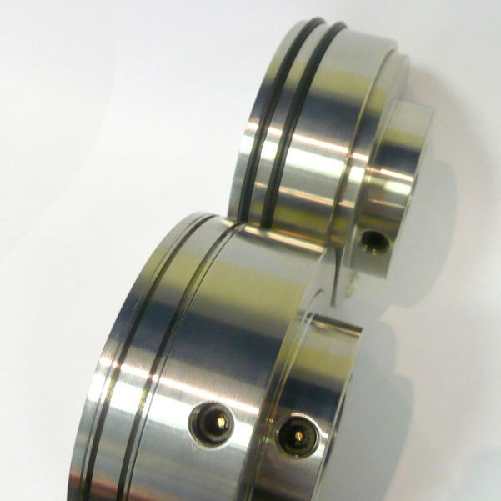

Top Shaft double, 2 x crease ribs

Bottom shaft, double female

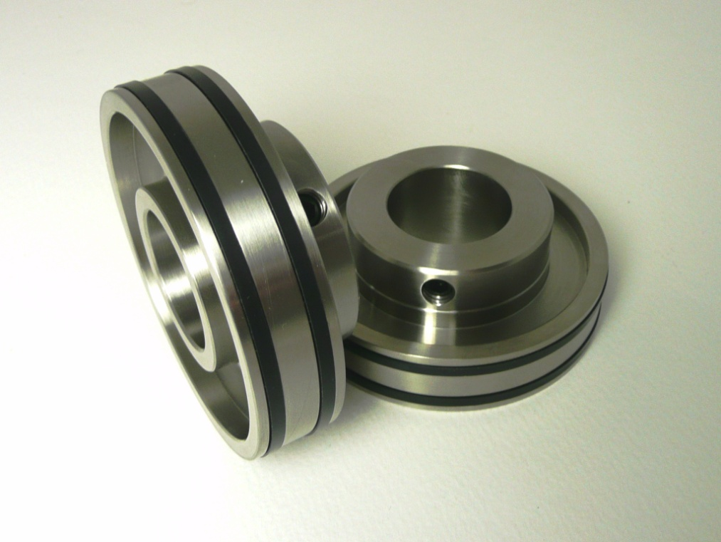

2 x Top Shaft Support Collars
Used to grip the sheets as the creases are applied

Aligning the Creasing units
With the crease ribs locked into the top crease units, align the BOTTOM SHAFT female channel units to the correct creasing position (left side being aligned with the edge of the clamp ) and then tighten the fixing screws
Slowly lower the top shaft crease units making sure the top crease ribs locate into the female channel on the bottom crease unit.
DO NOT TIGHTEN TOP SHAFT FIXING SCREWS
Slowly run a sheet of cover stock through the Spine & Hinge units.
As the cover travels through the crease units the loose top crease units automatically centralise to the optimum creasing position.
With the cover stock still gripped between the crease units tighten the fixing screws.
The machine is now ready to test.

